AKGEC/IAP/FM/02
Ajay Kumar Garg Engineering College, Ghaziabad
Department of ECE
Sessional Test-2

Course: B.Tech Semester: VII
Session: 2017-18 Section: EC 1,2,3
Subject: VLSI Design Sub. Code: NEC 703
Max Marks: 50 Time: 2 hour

Note : Answer all the sections.

Section-A

- Attempt all the parts. (5x2 =10)

- What is ratioed logic and ratioless logic.
- Define logical effort.
- What is parasitic delay.
- What is EDP and how it is better than PDP.
- Calculate the delay of following circuit using elmore delay model.
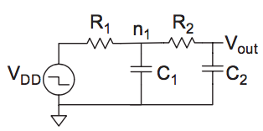
Fig.1

Section-B

- Attempt all the parts. (5x5 = 25)

- Derive the expression for voltage across pass transistor for transmission of logic ‘0’ and ‘1’.
- Explain the working of enhancement load dynamic shift register.
- What is interconnect engineering explain in detail.
- Explain the pipeline and parallel architecture for low power VLSI design.
- Explain with expressions the buffer insertion in interconnects to optimize delay.

Section-C

- Attempt all the parts. (2x7.5 = 15)

- Explain the crosstalk in interconnect and what are the methods to minimize the crosstalk.
12. Explain the electrical effort, logical effort, path effort and branch effort. In Fig-2 calculate electrical effort, logical effort, path effort, branching effort , parasitic delay and overall delay.

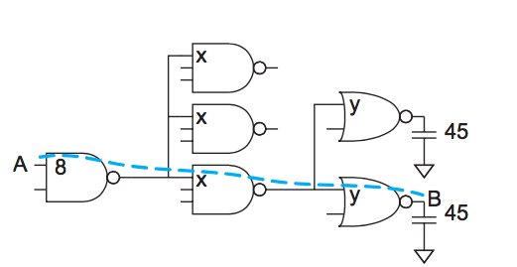
Fig 2. Parameters shown in figures are internal capacitances of logic gate.

